1. Objective of whole project.

Compare MADGE data to other machine learning algorithms like SVM and neural networks. Accuracy and speed will be the two most optimized features, with accuracy without overfitting as the most interesting piece to explore.

1. What was implemented last week.

Attempted to use a best calculation for sigma.

- Tensorflow data is manipulated to be stretched out to attempt to test sigmas

- Used the equation for calculating sigma between two points with distance calculation based on dimensions:

$$\sum_{1}^{Dim}{\frac{d_{j}}{\sum_{1}^{Set}{n_{i}}}\frac{D_{j}}{σ}}$$

Where d is the distance from the point on dimension j to point M, D is the range of dimension j, and the sum of n is the total sum of all the distances for each dimension.

Sigmas were plotted and calculated for a given range.

The spiral data was stretched out and an optimal sigma was found with testing.

Given the right sigma, accuracy is able to be in the 90s.

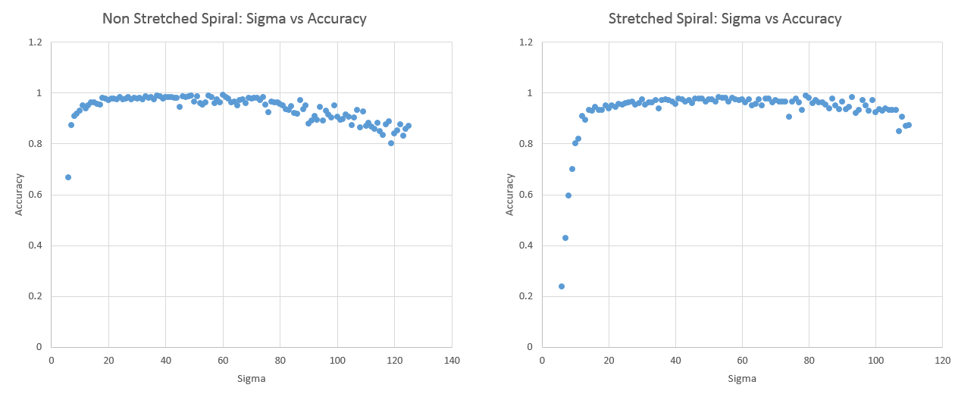

Two Spiral Stretched: 831.3599

Two Spiral Non-Stretch Range: 8.247

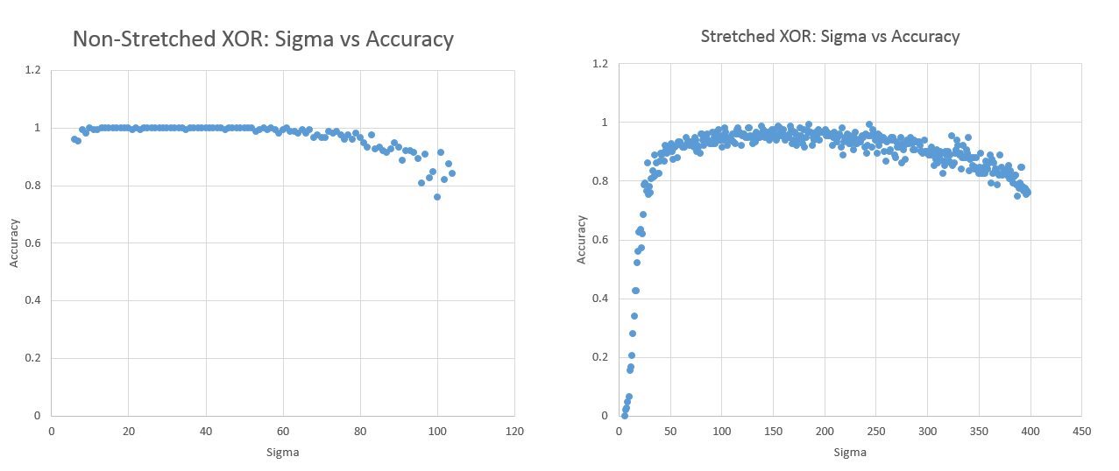

XOR Stretch Range: 3178.55297

XOR Non-Stretch Range: 8.2470265

Stretch range is the sum of ranges from all dimensions.

1. Plans for upcoming week.

I think I need to test the stretching range of the data for one data set to determine if there is a correlation.

Different data sets at different stretch ranges should have similar sigmas?

Apply another method that encapsulates the “shape” of the data better.

1. Objective of whole project.

Compare MADGE data to other machine learning algorithms like SVM and neural networks. Accuracy and speed will be the two most optimized features, with accuracy without overfitting as the most interesting piece to explore.

1. What was implemented last week.

- Used the updated sigma calculation on the test data set for 2 dimensional spiral data.

Graphing the 2-D data requires a lot of calculations, since it requires a higher resolution for a stretched out spiral data set. I am testing a higher resolution since the range is larger. This is sort of an example of that spiral data’s classification as of now.

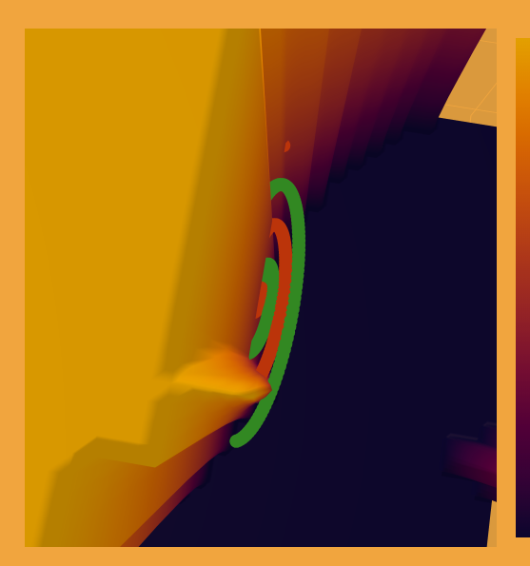

- Used the updated sigma calculation on the test data for n-dimensional MADGE data.

Accuracy is ~50% for this sigma calculation method. NaNs are being introduced, which is an indicator that the sigma being used is not large enough.

1. Plans for upcoming week.

Since code was updated for pointwise calculation, there had to be some tweaks to 2D classification methods. I will update the RUML as necessary. Continue to explore sigma calculation methods.